# JVC 170 User Guide

## The camera controls

Most of the configuration controls are on the left side of the camera. Most of the camera record and zooming functions are on the right. Yes, cameras are made for righthanders. Sorry my leftie friends!

## Most configuration controls are on the left side of the camera.

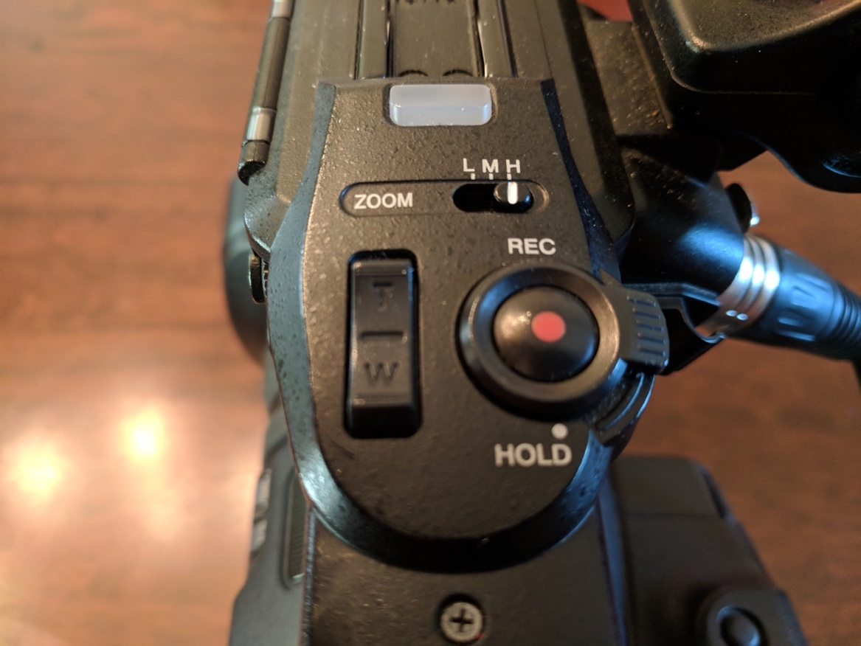

## Audio Channels

Lav mic into INPUT 1. Shotgun (camera) mic into INPUT 2.

Lav mic into input 1
Shotgun mic into input 2

Your audio dials should look like this. Channel 1 set to input 1. Channel 2 set to input 2. Audio input should be MIC+48V. Leave audio select in Auto for the moment.

Channel 1 to input 1
Channel 2 to input 2

Audio input to Mic+48V

Audio select to auto

## SD Card slots

Are on the left side, under the flip-open viewfinder. Put a card in slot A. Professional photographer George Garnica recommends putting your spare in your pocket so the camera doesn’t accidentally record to the wrong card (I’ve had this happen).

Put SD cars into slot A.
Put spare card into your pocket. 

Make sure your SD card is formatted properly: Menu thumb – system – media – format media.

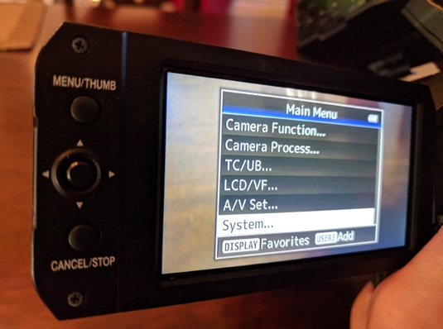 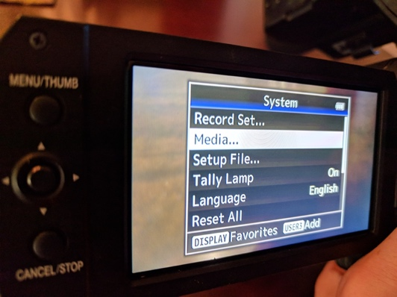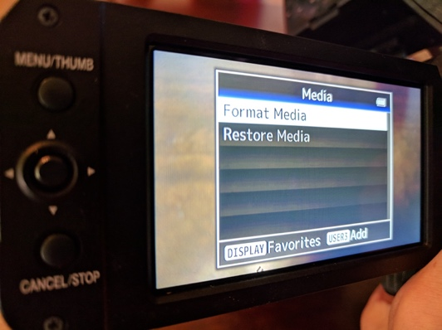

## Optical Image Stabilization

## While we’re here, that OIS button is for stabilization. Push that until you see an indication on your screen that looks like a hand surrounded by multiple parentheses. That will help decrease video shakiness. It will not eliminate it (yes, we’ll still know you’re off the sticks), but it can help.

## Shutter speed

When shooting news video, you will generally want your shutter speed to be double the frames per second of playback. TV playback is generally 30 frames per second, so you will want your shutter speed set to 1/60.

## Put SD cars into slot A. Put spare card into your pocket.

## White balance

The button for white balance is on the bottom left of your camera, by the lens. Zoom in on something white every time there is a lighting change to keep your video the proper color.

The knob surrounding the white balance button controls your iris.

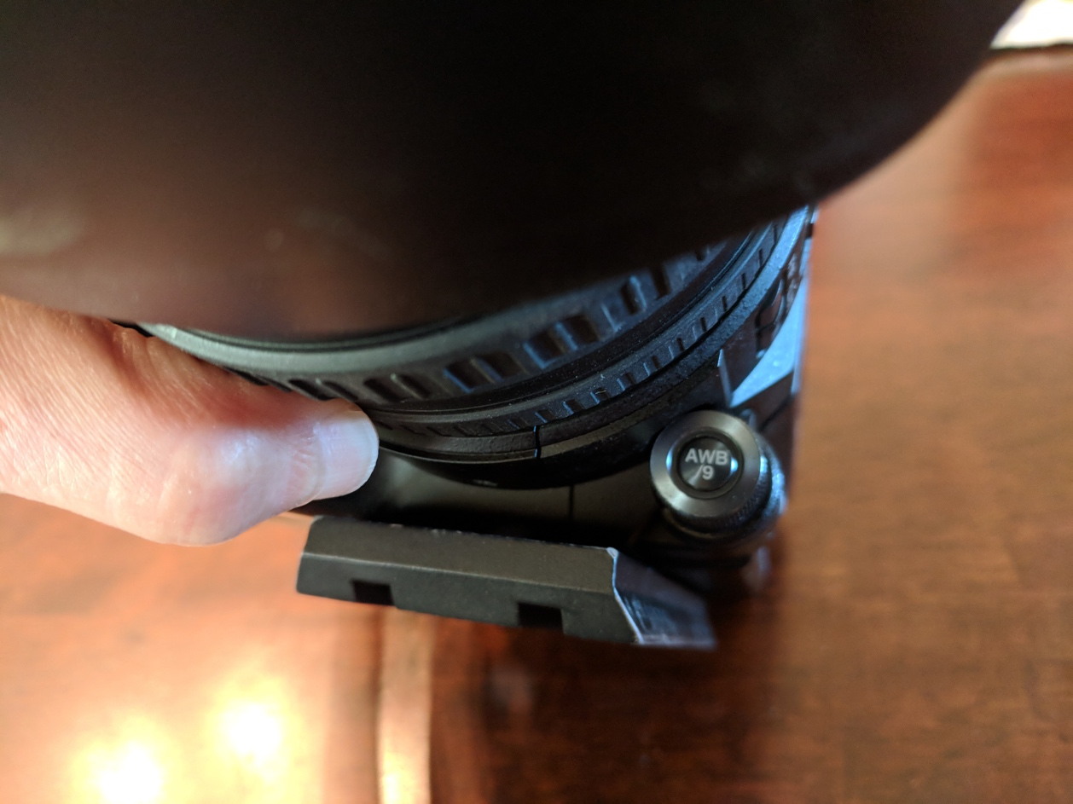

## ND filters

As a general rule, neutral density filters should be off if you are inside, and on if you are outside, particularly here in the Central Valley bright and hazy sunshine. Think of these as sunglasses for your camera. Pick the filter that gives you the best picture without losing detail in your video. Adjust your iris accordingly.

Off for inside
1/16 for outside

Please do not use your camera on full auto. It may decide to adjust all sorts of fun things at an inopportune time.

## Focus assist

This is actually a pretty nifty little button. It will outline what is in focus in blue if you are trying to adjust on the fly.

By the way, those rings on the camera lens are focus (closest to the lens) and zoom.

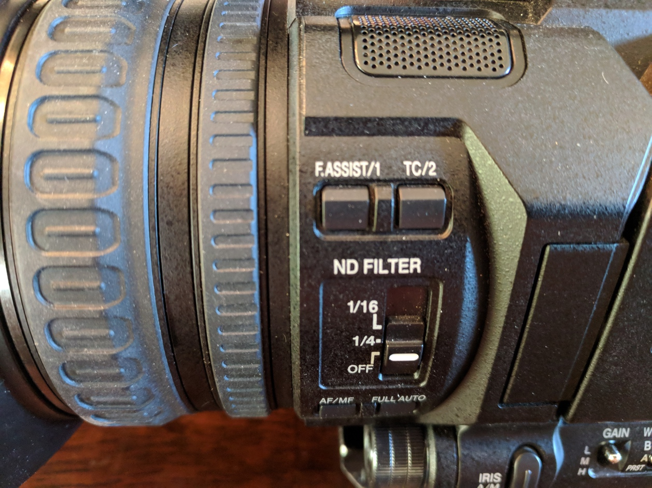

## Expanded focus

This can also help you tell if your shot is in focus. It actually does not change your physical shot, but zooms the display in so you can see your focus more clearly. Press it again and it bounces back.

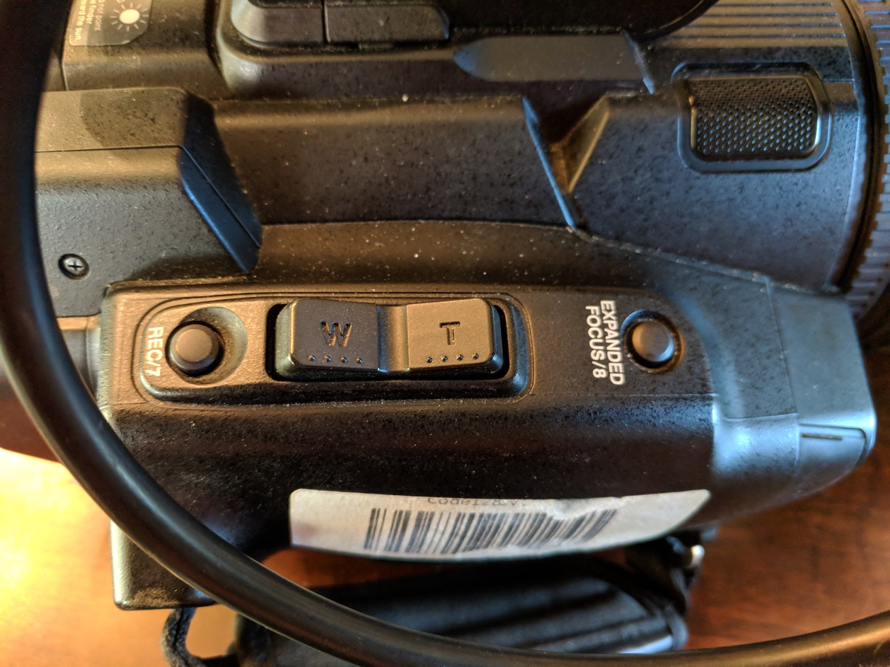

## Playback

You should always check your video to make sure it recorded video and audio as you think it did.

Press the mode button next to the power switch.

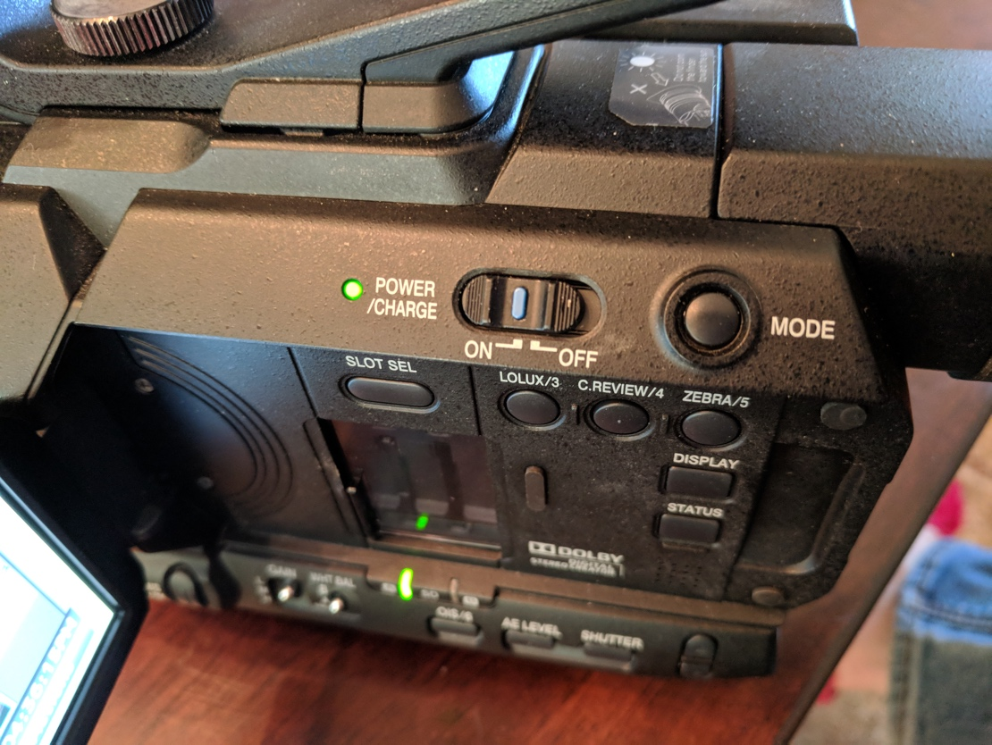

Using the arrow control, scroll through your clips to watch back the one you want. Press the arrows button to play. Cancel to stop. Press mode again to go back to recording.

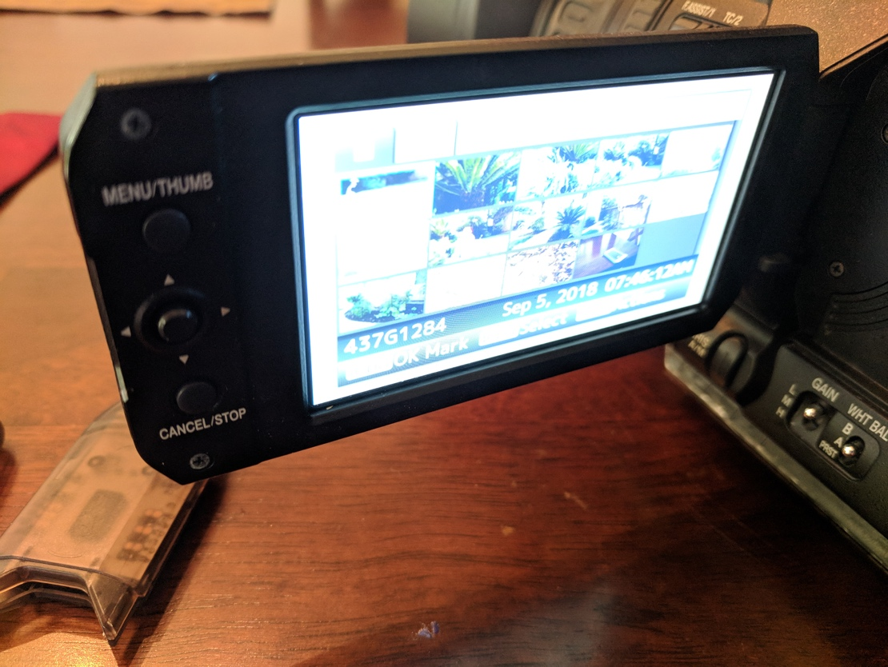

To listen to your audio, the headphone jack is hidden under a panel under the eyepiece and battery.

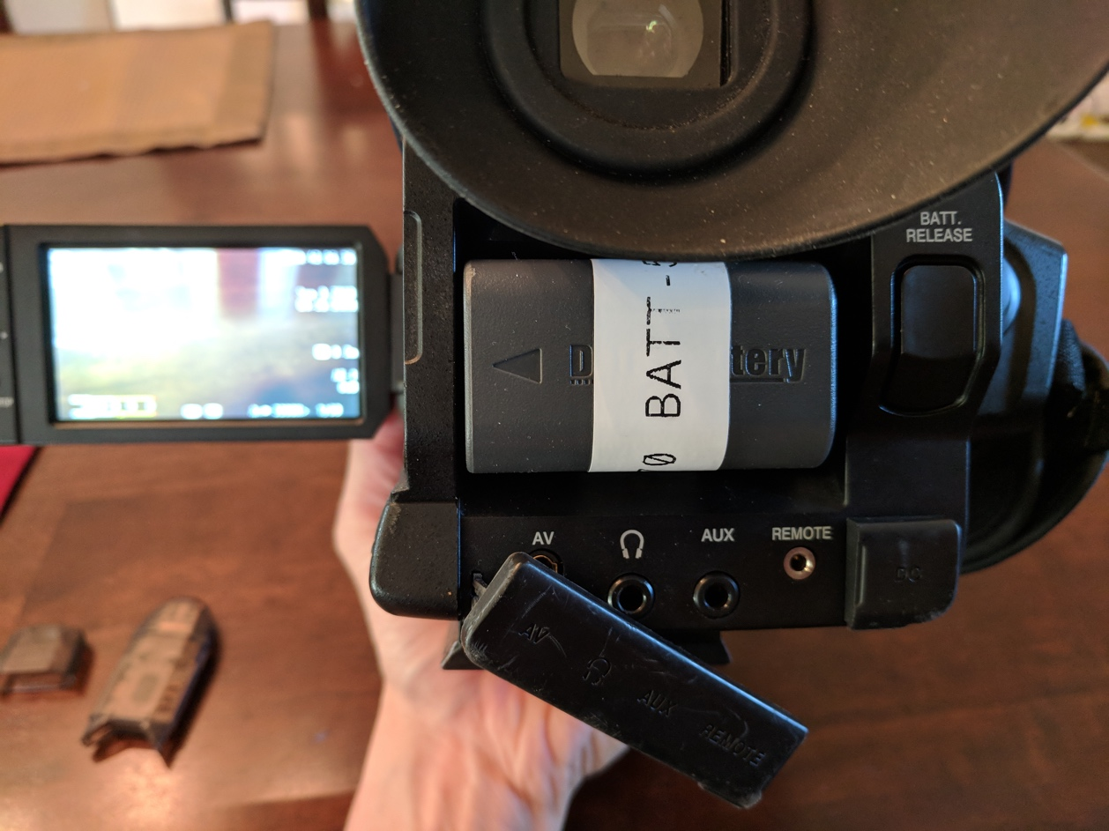

Don’t forget your lights, microphone, batteries, and tripod!

Happy video gathering!

Thank you to KSEE’s George Garnica for pointing out the “most useful” buttons for journalism students.

Guide by Carey Higgins-Dobney for MCJ 115 Fall 2018.